AWS ARCHITECTURE

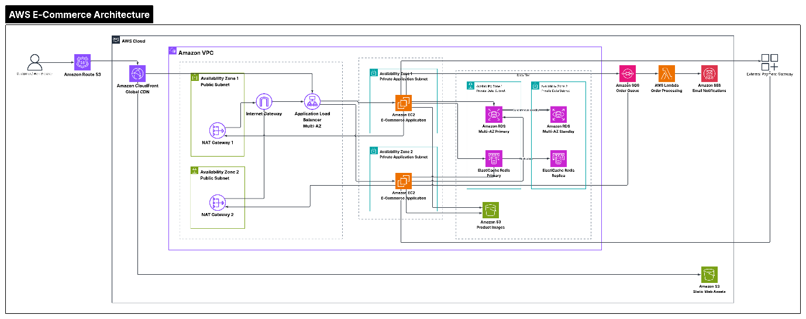

Here is the step-by-step WORK-FLOW of this AWS E-Commerce architecture, following the exact path a user request takes through the system:

User Request & Edge Acceleration
DNS Resolution: A user accesses the website via their browser. Amazon Route 53 resolves the domain name and routes traffic to the optimal edge location.
Content Delivery: Traffic passes through Amazon CloudFront (Global CDN).
Static web content (HTML, CSS, static media) is served directly from an Amazon S3 static asset bucket.
Dynamic requests are forwarded directly to the Virtual Private Cloud (VPC).

Network Entry & Load Balancing (Public Tier)
VPC Access: Dynamic traffic enters the VPC via the Internet Gateway into Public Subnets distributed across two Availability Zones (AZ1 and AZ2).
Traffic Distribution: The Application Load Balancer (ALB) receives the incoming request and routes it to an active application server in the private subnet.
Outbound Internet Access: NAT Gateways in the public subnets allow private application instances to make outbound internet calls (e.g., fetching third-party API data) while blocking incoming external connections.

Core Application & Data Tier (Private Tier)
Compute Processing: The request reaches an Amazon EC2 instance hosting the E-Commerce Application inside a Private Application Subnet (spread across AZ1 and AZ2 for high availability).
Caching Layer: For fast reads (product catalogs, session state), EC2 queries ElastiCache Redis (Primary in AZ1, Replica in AZ2).
Database Layer: Transactional data (user details, order history) is read/written to Amazon RDS (Primary SQL DB in AZ1 with synchronous Multi-AZ Standby in AZ2 for failover).
Media Storage: Product images and media files are stored in a dedicated Amazon S3 product image bucket.

Asynchronous Order Processing & External Integration
Message Queuing: When a customer places an order, the EC2 server pushes the order details into Amazon SQS (Order Queue) to decouple order creation from processing.
Serverless Execution: AWS Lambda automatically consumes messages from the SQS queue and handles background business logic (order verification, fulfillment trigger).
Customer Notifications: Lambda uses Amazon SNS to dispatch order updates and transactional emails/SMS to the customer.
Payment Processing: Lambda securely communicates with an external Payment Gateway to authorize and complete the payment transaction.

Here is how an INVOICE REQUEST flows step-by-step through this architecture, from the moment a user clicks a button to the final document delivery:
Request Ingress & Endpoint Resolution
User Request: A user or external application sends an HTTP request (e.g., POST /generate-invoice) to create an invoice.
DNS Resolution & Encryption: Amazon Route 53 resolves the custom domain name and routes traffic to the API Gateway. ACM (AWS Certificate Manager) decrypts the incoming HTTPS traffic at the edge to ensure secure transport.
API Routing & Orchestration
API Gateway Entry: Amazon API Gateway validates the incoming request payload and passes it downstream.
Orchestrator Execution: The Invoice Orchestrator Lambda triggers inside a private application subnet. It authenticates the client, retrieves necessary API keys or configuration settings securely from AWS Secrets Manager, and verifies permissions using AWS IAM.

Asynchronous Decoupling (Queueing)
Task Offloading: Instead of generating the document synchronously—which risks timeouts—the Orchestrator Lambda places a message containing the invoice parameters onto an Amazon SQS queue (or triggers an Amazon SNS event).
Immediate Response: API Gateway immediately returns a 202 Accepted response back to the client along with a job ID, freeing up the client interface without waiting for the document to build.
Worker Processing & Generation
Worker Pick-up: The Invoice Generation Worker Lambda consumes the task from the SQS queue.
Data Fetching: The worker queries Amazon RDS (PostgreSQL/Aurora) in the private database subnet to fetch customer records, line items, and pricing. If outbound internet access is needed for third-party integrations, the worker routes traffic through the NAT Gateway and Internet Gateway.
Document Creation: The worker compiles the raw data into a PDF or designated invoice document format.
Storage, State & Security
S3 Persistence: The generated invoice PDF is uploaded to an Amazon S3 bucket.
KMS Encryption: The document in S3 and data in RDS/DynamoDB are automatically encrypted at rest using keys managed by AWS KMS.
State Update: The processing status (e.g., COMPLETED, S3 file location) and transactional metadata are updated in Amazon DynamoDB and Amazon RDS.
Notification & Client Retrieval
Notification Dispatch: A Notification Lambda triggers an Amazon SNS topic to send an email, webhook, or push notification to the end user informing them that their invoice is ready.
Direct Access: The user downloads the generated PDF directly from Amazon S3 (often served via Amazon CloudFront using a pre-signed URL for temporary, secure download access).
Cross-Cutting Observability
Monitoring & Audit: Throughout the entire lifecycle, Amazon CloudWatch continuously collects execution logs, latency metrics, and error rates from Lambda functions, API Gateway, and database endpoints to alert engineers of any processing failures.

